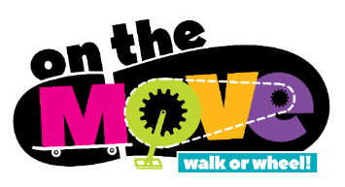
[Insert school name] School is On the Move!

Our school continues to work with the Simcoe Muskoka District Health Unit and other partners to encourage and support more walking and wheeling to and from school. The initiative is called On the Move.

Help your kids build the skills and confidence they need for cycling and walking to school or the school bus stop.

Here are some basic tips for parents/guardians.
- Younger children need to develop the cognitive (thinking) and physical skills to make safe judgments about road crossing and traffic. It very much depends on the complexity (difficulty) of the street environment.
- Young children can navigate simple street structure but the skills to navigate more complex environments develop around the ages of 9 to 11.
- While your children are developing skills, walk with your children and talk to them about pedestrian safety.
- To cross a street safely by themselves, children need three important skills:
Able to decide on and use a safe crossing route.
Able to properly assess a vehicle’s speed.
Able to judge safe gaps in traffic.
Find out more about pedestrian safety from Parachute Canada.

Check out these additional resources:
The route to school should always start with safety
Safety Tips for Parents: 11 steps to increase your child’s safety walking to school
Tony the Street-Wise Cat – video series
Cycling Skills: Ontario’s Guide to Safe Cycling & the Young cyclist’s guide
How to teach your child to ride a bike
For new cyclists, developing confidence is key
How to choose the right size and type of helmet for your child
How to teach kids to pedal their bikes properly

