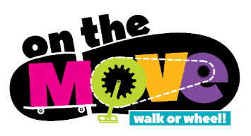
[Insert school name] School is On the Move!

Our school is working with the Simcoe Muskoka District Health Unit and other partners to encourage and support more walking and wheeling (e.g., bicycle, scooter, skateboard etc.) to and from school. The initiative is called On the Move.

On the Move is about working together to create safe and supportive school environments to help our children build physical activity into their daily routine and develop healthy habits that can last a lifetime.

These are just a few of the many benefits:

- Improved physical health and mental wellbeing.
- Enhanced readiness for learning, and social opportunities.
- Building skills, confidence, and independence.
- Creating a healthier and safer school environment with fewer vehicle emissions and traffic congestion.

For students who get to school by bus, some of the same benefits can come from walking to the bus stop. Riding the school bus instead of being driven to school also helps to reduce the number of cars moving through the school neighbourhood and at the school.
At times, when students need to be driven to school, consider parking the car one or more blocks away from the school and walking part of the way.

Find out more from www.simcoemuskokaonthemove.ca

