Make Walk & Wheel Days Extra Fun!
Ideas from Schools Across the Region

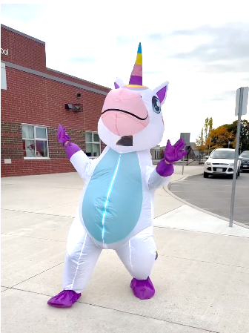
Walk and Wheel Days are a great way to get students moving, build school spirit, and celebrate active travel! Here are some fun, easy ideas that schools have used to make the day even more engaging.

Fun Extras
- Sidewalk Chalk Stations – Let students decorate the path with positive messages or “walk & roll” art
- Music – Create a festive arrival zone with upbeat tunes
- Bubbles – Student “bubble makers” can use bubble wands to welcome others and fill the air with bubbles as they arrive
- Photo Ops – Staff, mascots, or volunteers can dress up in fun costumes (Garfield, superheroes, school mascots) for pictures at arrival
- Student Cheering Squad – Older students or leadership teams can welcome walkers and rollers with signs and cheers
- Volunteer Spirit Crew – Encourage volunteers to line the route to school wearing identifying hats, vests, or lanyards to cheer students on
- Dress festive – Encourage everyone to wear spirit colours or special colours to school (e.g., rainbow day)

Incentive Ideas
- “Fill the Bike Rack” Challenge – See if the school can fill every bike rack spot!
- Classroom Challenge – Track participation and award the class with the highest number of walkers/wheelers
- Local Business Support – Ask nearby businesses to offer small incentives (stickers, water bottles, or pencils)
- Parent Council Involvement – Work with your Parent Council to help organize prizes, music, or refreshments.

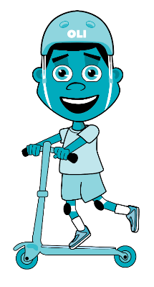
Keep it Simple and Celebrate Participation
Even small touches such as smiles, cheers, and chalk art, can make a big difference. The goal is to celebrate students choosing active travel and to make it a memorable, community-building day!

