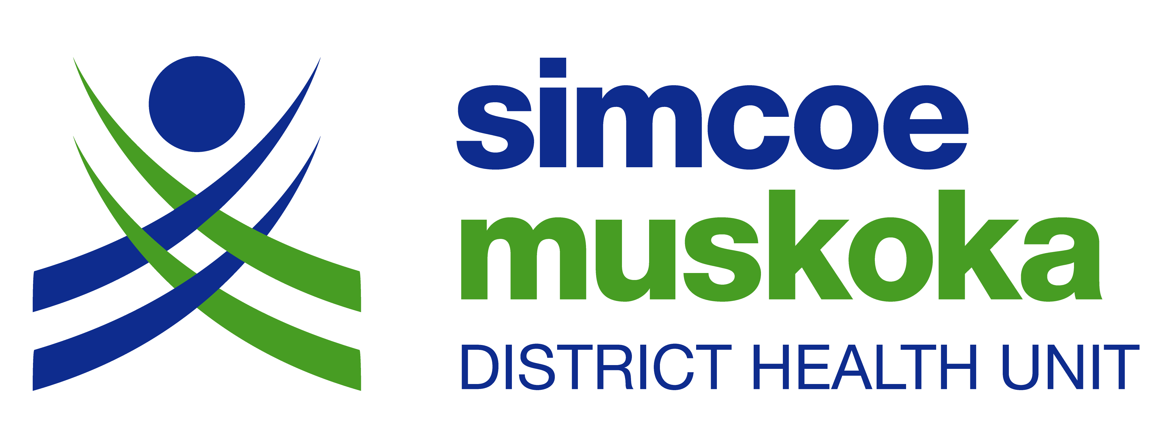
Simcoe Muskoka District Health Unit
Clinical Service Department
15 Sperling Drive
Barrie, ON L4M 6K9
Telephone: 705.721.7520 - Fax: 705.733.7738
Email: HC.CD@smdhu.org
NOTICE OF PERSONAL SERVICES SETTING (PSS) OPERATION
If you are currently in operation, you are required to complete this form and submit
it to us by October 31, 2018.

All owner/operators of PSS are to submit this form at least 14 days prior to opening, adding new services or renovations.

Please Type or Print All Entries

Premises Name:

New Premises Existing Premises Addition of Services Renovation
Premises Physical Description
Municipality: |  | Township: |  |  | Lot No.: |  | Concession:
Premises Mailing Address: |  |  |  | City: |  | Postal Code:
Premises Phone Number: |  |  | Premises Fax Number (if applicable):
Premises email: |  |  | Premises website (if applicable):
Owner’s Name:
Is the Operator information the same as the Owner information listed above? Yes No
If no, list Operator’s Name:
Operational Information
Open Year- round Open Seasonally – list months open:

Select all days of the week the premises is open and list hours of operation:
Day | Monday | Tuesday | Wednesday | Thursday | Friday | Saturday | Sunday
Open Hours

Services:  (check all that apply) | Aesthetics: Hair Barbering Manicures Pedicures Facials Waxing Body scrubs/wraps
 | Medical Aesthetics: Injectables/Fillers Microdermabrasion Laser/light treatments Medical facials
Body Modification:
Ear piercing Body piercing Tattooing
Microblading/microneedling Permanent make-up Dermal implants
Extreme body mod (e.g. scarification, tongue splitting, ear shaping)
 | Other – please specify:

