Sample School Newsletter Insert
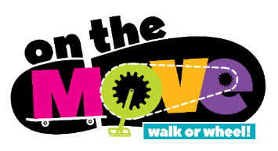

Walking and wheeling to school is still important!

We are pleased to let our school community know that (school name) will continue to participate in the (school name) On the Move initiative to promote and support walking and wheeling to school.

Helping our children to be active outdoors as much as possible every day may be more important now, than ever before, for physical and mental well-being.

Walking and cycling or wheeling (e.g. skateboarding, rollerblading and scooting
etc.) is still considered a safe and healthy choice during the Covid-19 pandemic when we take steps to protect ourselves and others.

When parents need to drive, please park the car one or more blocks from the school site and walk the rest of the way. This cuts down on too many cars in the area of our school, reduces harmful air pollution, and student safety concerns due to traffic. Let’s all do our part to keep one another safe and healthy.

