SCS Site Scoring, September 2020
Score card created and completed by the SCS Site Selection Advisory Committee in conjunction with Linda Loftus, Broker – Squarefoot Commercial Group, squarefoot.ca
For more information on process involved in site selection and scoring please visit: https://www.simcoemuskokahealth.org/Topics/Drugs/opioids/Supervised-consumption-sites/Site-Selection-Advisory-Committee#_

Contents | Page
Ranking of sites | 2
Rationale for ranking of sites | 3-7
Definition and direction for scoring | 8-10

Scoring of Sites for Ranking

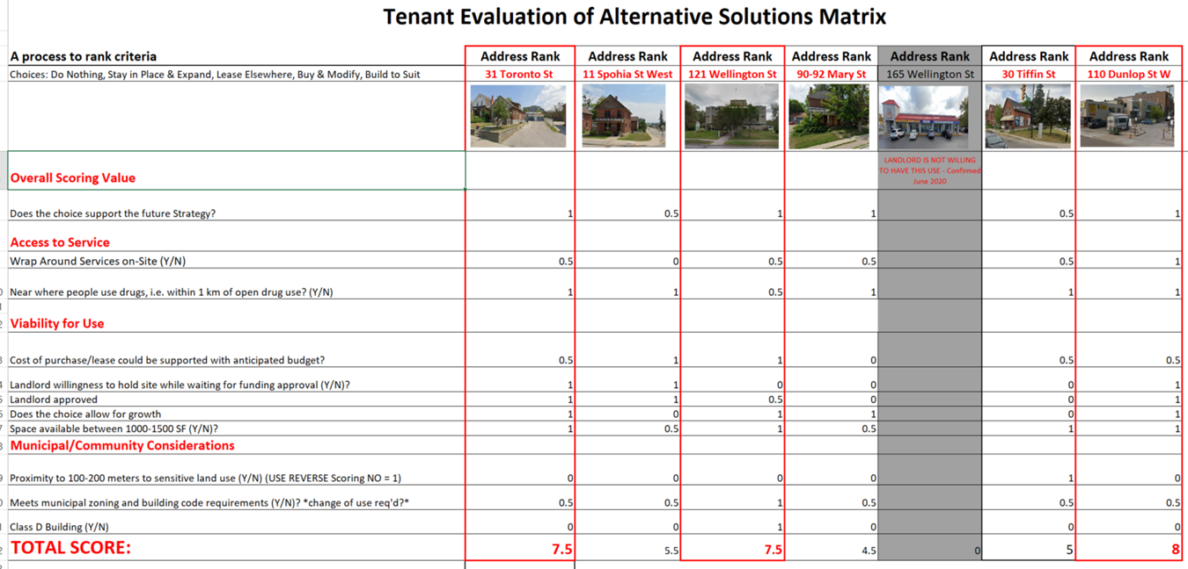

Rationale for Ranking of the Sites

 | 31 Toronto St | 11 Sophia St West | 121 Wellington St West | 90A-90B Mary St |  | 165 Wellington St West | 30 Tiffin St | 110 Dunlop St West Unit 4
Overall Scoring
Does the choice support the future Strategy | Score = 1.0  The square footage and layout of this building is such that it could accommodate a SCS | Score = 0.5  The square footage of the main floor may not be sufficient to house all of the required components of a SCS | Score = 1.0  The physical space would support the strategy, however the landlord is only willing to lease the space for the SCS if the upper level larger space is leased first | Score = 1.0  Building is a semi-detached home; with extensive retrofitting/ renovation, space available would support the strategy.  This site involves the purchase of the property |  | This site location was brought forward by an Advisory member. It is no longer considered an option as the landlord is not supportive of using the site for a SCS. This was confirmed with the landlord in June 2020 | Score = 0.5  The square footage and layout could accommodate a SCS.  This site involves purchase of the property | Score = 1.0  The square footage and layout of this building is such that it could accommodate a SCS
Wrap around Services on site | Score=0.5  There is potential to provide touchdown services because of the space available; there is also potential for additional space to become available for use by a community agency | Score= 0  There is limited space available to accommodate touch town services | Score= 0.5  Medical services are available on site in the form of a medical walk-in clinic; there is potential to provide touchdown services because of the space available | Score=0.5  There is potential to provide touchdown services because of the space available |  | N/A | Score=0.5  There is potential to provide touchdown services because of the space provided | Score=1.0  There is potential to provide touchdown services because of the space available. There is also a methadone clinic within the same building, as one option for treatment of opioid use disorder.
 | 31 Toronto St | 11 Sophia St. W | 121 Wellington St. W | 90 A – 90 B Mary St. |  | 165 Wellington St. W | 30 Tiffin St. | 110 Dunlop St. W unit 4
Near where people use drugs, i.e. within 1 km of open drug use? (Y/N)  Note: Scoring for yes is based on mapping of overdose visits to ED and EMS call data, and Advisory committee input. | Score 1.0 (yes) | Score 1.0 (yes) | Score=0.5  site is further away from higher areas of substance use but close enough for access; is also on a bus route | Score 1.0 (yes) |  | N/A | Score 1.0 (yes) | Score=1.0 (yes)
Viability for use
Cost of purchase/lease could be supported with anticipated budget | Score = 0.5  The costs of retrofitting this site to accommodate a SCS is unknown and may exceed capital funding received by Ministry of Health; the site would require a complete retrofitting of the existing shell | Score = 1.0  Lease costs would likely be supported and costs of retrofitting would be manageable | Score = 1.0  Lease cost would likely be supported by anticipated budget; retrofit of space should be minimal | Score = 0  Property would require purchase which is not in the current anticipated budget for CMHA |  | N/A | Score = 0.5  Property would require purchase which is not in the current anticipated budget for CMHA | Score = 0.5  The size of the space is large; rental costs may exceed anticipated budget, however the space is already accessible which may decrease capital costs
 | 31 Toronto St. | 11 Sophia St. W | 121 Wellington St. W | 90 A – 90 B Mary St. |  | 165 Wellington St. W | 30 Tiffin St | 110 Dunlop St W, unit 4
Landlord willing to hold site without payment while awaiting funding approval | Score = 1.0  Landlord is supportive of harm reduction and is willing to hold site; Currently site is used only for storage by the landlord | Score = 1.0  Landlord is supportive of harm reduction and is willing to hold site | Score = 0  Landlord is only willing to hold the site if the larger upper floor of the building is rented/leased out | Score = 0  Property would require purchase, which would make it unavailable for this purpose. |  | N/A | Score = 0  Property would require purchase, which would make it unavailable for this purpose | Score = 1.0  Landlord is supportive of harm reduction and is willing to hold site
Landlord approved | Score = 1.0  Landlord is supportive of harm reduction and the use of the site as a SCS | Score = 1.0  Landlord is supportive of harm reduction and the use of the site as a SCS | Score = 0.5  The landlord approves of the use for a SCS if the above parameter is met | Score = 0  Property is only available for sale, landlord support not assessed. |  | N/A | Score = 0  Property is only available for sale, landlord support not assessed. | Score = 1.0  Landlord is supportive of harm reduction and the use of the site as a SCS
Does the choice allow for growth | Score = 1.0  The space is large and can be retrofitted to allow for co-location of other services or growth as necessary | Score = 0  Overall square footage on the main floor would not allow for growth; square footage of the main level is less than 1000 square feet; the site is not accessible and would need an elevator for use of the second floor | Score = 1.0  The space is large enough to support potential growth in the future | Score = 1.0  The physical space available is large enough to support potential growth in the future |  | N/A | Score = 0  The space was not fully assessed by the SCS Site Selection Advisory given the inability to consider due to purchase requirements | Score = 1.0  The space available is quite large and would support future growth
 | 31 Toronto St. | 11 Sophia St. W | 121 Wellington St. W | 90 A – 90 B Mary St. |  | 165 Wellington St. W | 30 Tiffin St | 110 Dunlop St. W. Unit 4
Space available is at least 1000-1500 SF | Score = 1.0  Space available on the main level is between 1000 – 1500 square feet | Score = 0.5  Overall square footage of the space is between 1000 – 1500 sq feet, however this square footage is the total of two levels; an elevator would need to be installed for accessibility | Score = 1.0  Overall square footage is greater than 1500 sq feet | Score = 0.5  Space is currently a two story semi-detached home; space could be retrofitted to be 1000 square feet per level |  | N/A | Score = 1.0  Space available is between 1000-1500 sq. feet | Score = 1.0  Space available is greater than 1500 feet
Municipal/Community Considerations
Proximity of 100-200 m to sensitive use area (see Definitions and direction for scoring)  Note: distances for the sites were provided by the City of Barrie upon request. | Score = 0  Site is within 80 m of a park. Community mitigation strategies would need to be developed to support the site | Score = 0  Site is 95 m to a school.  Community mitigation strategies would need to be developed to support the site | Score = 0  Site is 120 m to a child care centre.  Community mitigation strategies would need to be developed to support the site | Score = 0  Site is 60 m from a park.  Community mitigation strategies would need to be developed to support the site |  | N/A | Score = 1.0  Site is 230 m from a school | Score = 0  Space is 90 m to a park.  Community mitigation strategies would need to be developed to support the site
 | 31 Toronto St. | 11 Sophia St. W | 121 Wellington St. W | 90A – 90B Mary St |  | 165 Wellington St. W | 30 Tiffin St | 110 Dunlop St. W. unit 4
Meets municipal zoning and building code requirements  Note: zoning and building codes for the sites were provided by the City of Barrie upon request | Score = 0.5  Current zoning is  C 2-1 | Score = 0.5  Current zoning is C2-1 | Score = 1.0  Current zoning is C2, | Score = 0.5  Current zoning is C2-1 |  | N/A | Score = 0.5  Current zoning is C1-1 | Score = 0.5  Current zoning is C1-1
Class D Building  Note: Building Code use designations for the sites were provided by the City of Barrie upon request | Score = 0  Site is not a class D building  -a change of use would be required | Score = 0  BC use is unknown  - a change of use may be required | Score = 1.0  Site is already considered a Class D Building  -no change of use required | Score = 0  Site is not a class D Building  -a change of use would be required |  | N/A | Score = 0  BC use is unknown  -a change of use may be required | Score = 0  Site is not a class D Building  -a change of use would be required
Definitions and directions for scoring of potential SCS sites in Ward 2 Barrie

Overall Scoring
Does the choice support the future strategy |  |  |  |  | Overall, does the location/building meet the needs of a potential SCS in Ward 2 of the City of Barrie?  Yes = 1  Potentially = 0.5  No = 0
Access to service
Wrap Around Services – assessing whether services exist in the proposed location already, whether they could potentially exist either as a co-tenant or with drop down days/times, or whether wrap around services would not be available on site |  |  |  |  | Are wrap around services available on site, that is, tenancy in building includes services defined in CTS criteria as required?  Yes = 1  Potentially, co- tenancy or touch down days/times could be incorporated into the plan = 0.5  No, services are not available and site space is not sufficient to accommodate additional services = 0
Near where people use drugs, i.e. within 1 km of open drug use |  |  |  |  | The site is in the area of greatest substance use based on mapping of overdose visits to ED and EMS call data, and Advisory committee input: Yes = 1;  The site is in an area of high use but not the area of highest use based on mapping of overdose visits to ED and EMS call data, and Advisory committee input: = 0.5  The site is not in an area of high rates of substance use based on mapping of overdose visits to ED and EMS call data, and Advisory committee input: = 0
Viability for use
Cost of purchase/lease could be supported with anticipated budget |  |  |  |  | Purchase or lease could be supported by anticipated budget, based on funding received by similar municipalities for SCS/CTS  Yes = 1  Potentially with some additional funding = 0.5  No, cost is prohibitive = 0
Landlord willing to hold site without payment while awaiting funding approval |  |  |  |  | Landlord is willing to hold site  Yes = 1  Landlord may be willing to hold the site = 0.5  0 = No, Landlord is not willing to hold site = 0 (No)
Landlord approved |  |  |  |  | landlord is willing to house a SCS/CTS in their location  Yes = 1  Maybe, landlord may consider use of the space for a SCS/CTS  Potentially = 0.5  Landlord is not willing to house a CTS/SCS in their space  No = 0
Does the choice allow for growth |  |  |  |  | Is there enough space available to allow for growth  Yes = 1  Maybe, could additional space become available or be easily added through renovation= 0.5  Additional growth would not be available  No = 0
Space available is at least 1000-1500 square feet |  |  |  |  | Accessible main level space available is at least 1000 – 1500 square feet  Yes = 1  Space available totals at least 1000 – 1500 square feet in a two level building and is not easily accessible (i.e. due to stairs)  Potentially = 0.5  Space available is less than 1000 square feet  No = 0
Municipal/Community Considerations
Proximity to sensitive land use areas – within 100-200 meters of sensitive land use  Based on information requested and received from The City of Barrie |  |  |  |  | *Use reverse scoring, No is the positive response  Site is not within 100-200 meters of sensitive land use area  No= 1;  Site is within 100-200 metres of sensitive land use but mitigation strategies could be easily implemented and the location of the site may benefit the sensitive land use – Potentially = 0.5,  Site is within 100-200 metres of sensitive land use and mitigation strategies would be prohibitive  Yes = 0
Meets municipal zoning and building code requirements  Based on information requested and received from the City of Barrie |  |  |  |  | Site meets requirements  Yes = 1  Changes in zoning could be applied for and building could be updated to meet code requirements  Potentially = 0.5  Changes to municipal zoning or building code requirements would be prohibitive  No = 0
Class D Building  Based on information requested and received from the City of Barrie |  |  |  |  | Is the building code use of site a class D designation  Yes = 1  No = 0

