# Clinic Printer Instructions

**To setup the printer**

Here are the icons I will be referencing throughout the guide:



1. Flip the printer over and remove the back panel.
2. Take out the battery and small piece of paper. Reinsert battery.
3. Plug printer in and turn it on. You should be brought to a screen that says READY with wifi and battery info.  
     
   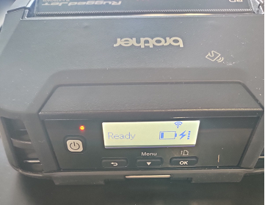

**Pairing a printer with a hub**

1. Click the Menu button. You should see **WLAN**. Click OK.
2. Click Menu again. You should see **Mode**. Click OK on Mode
3. Click Menu until **Infrastructure** is highlighted. Click OK.
4. Click the back arrow and go to **WLAN** again. Click OK.
5. Click Menu twice and you should see **WPS**. Click OK on that.
6. Bring the printer to the hub (or vice versa) you want to connect it to, then click OK on **Button Push** on the printerscreen.
7. There is a small WPS button on the side of the hub. With the printer near it, press and hold the button for approximately 20 seconds.  
     
   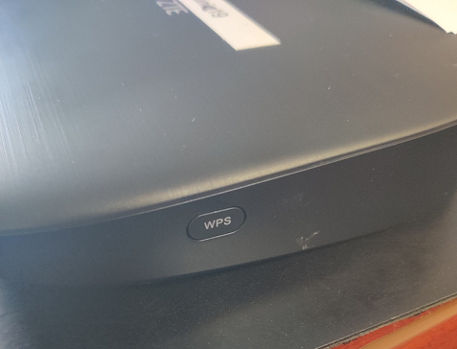
8. Your printer screen will change to **Finished** when it is paired with that hub.

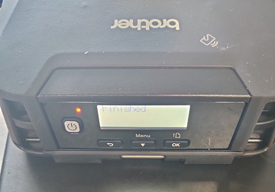

1. Click the back arrow on the printer, then click the Menu button until you get to **Media**. Click OK.
2. Select **Autodetect**, click OK. The printer will automatically detect the paper size and print a small sample.

**How to Print  
NOTE: YOU NEED TO BE CONNECTED TO THE SAME HUB AS THE PRINTER IN ORDER TO PRINT TO IT!**

1. Go to the webpage/area you would like to print. If it’s a clinic receipt, *you must DOWNLOAD it after preparing it and then print* *from there.*
2. Click the box and up arrow icon, then select Print  
     
   
3. Click the Printer menu to select a printer.  
     
   
4. 
5. Click **Print** at the top of the page.