
If s

Immunization Directive

Number:
Topic: | Administration of mRNA COVID-19 Vaccine
Approved:
Reviewed:
Revised:

Procedure

Administer intramuscularly mRNA COVID-19 vaccines.

Involvement of a Delegated Controlled Act: Yes X No

Controlled Act #5: Administering a substance by injection or inhalation. This is a controlled act, which is in the scope of nursing practice. A member of the College of Nurses may perform a procedure within the controlled acts authorized to nursing if a physician, dentist, chiropodist, nurse practitioner or midwife orders it.

Controlled Act #8: Prescribing, dispensing, selling or compounding a drug as defined in the Drug and Pharmacies Regulation Act, or supervising the part of a pharmacy where such drugs are kept.

Delegation of the Controlled Act

- This delegation applies to all (insert staff designation to be included) employed by the (insert organization) who have the knowledge, skills and judgment to administer the vaccine safely.

- Delegation of Controlled Acts (such as the administration of a vaccination) is acknowledged by the College of Physicians and Surgeons as falling under circumstances where the Controlled Act may be delegated in the absence of a physician order and in the absence of the doctor-patient relationship.

- Identification of Risks: The risk of treatment includes the potential for a serious reaction or allergy along with the possibility that the client will experience medication side effects. These risks are minimized by reviewing contraindications and medical history and by instructing clients where possible on how to reduce the occurrence or severity of side effects.

- Insert reference to any other applicable policies (Delegation of Acts, Directives, Consent).

Indications

The following mRNA vaccines are indicated for active immunization to prevent coronavirus disease 2019 (COVID-19) caused by severe acute respiratory syndrome coronavirus 2 (SARS-CoV-2) for primary series or booster doses and available in SMDHU clinics:

- SPIKEVAX® (Moderna) XBB.1.5 monovalent mRNA COVID-19 vaccine (0.10 mg/mL) – can be used for those 6 months and up
- COMIRNATY® (Pfizer 30 mcg/0.3 mL) XBB.1.5 monovalent mRNA COVID-19 vaccine – can be used for those 12 years of age and older
- COMIRNATY® (Pfizer 10 mcg/0.3 mL) XBB.1.5 monovalent mRNA COVID-19 vaccine for 5- to 11-year-olds (to be available late in October)
- COMIRNATY® (Pfizer 3 mcg/0.2 mL) XBB.1.5 monovalent mRNA COVID-19 vaccine for those 6 months through 4 years of age (to be available late in October)
- SPIKEVAX® Bivalent (Moderna) (elasomeran/davesomeran) Original/Omicron BA.4/5 COVID-19 mRNA vaccine (0.10 mg/mL) – can be used for those 6 months and up
- COMIRNATY® Bivalent (Pfizer 30mcg/0.3mL) Original and Omicron BA.4/BA.5 COVID-19 mRNA vaccine – can be used for those 12 years of age and older
- COMIRNATY® Bivalent (Pfizer 10 mcg/0.2 mL) Original and Omicron BA.4/BA.5 COVID-19 mRNA vaccine – can be used for those 5 to 11 years of age

Dosage and Administration:

COVID-19 XBB.1.5 vaccine is the recommended vaccine at this time to give individuals a better immune response against currently circulating strains, compared to earlier formulations of COVID-19 vaccine.

Consistent with NACI, the Ministry of Health recommends a dose of the COVID-19 XBB.1.5 vaccine for individuals in the authorized age group (i.e. 6 months and older) who have been previously vaccinated against COVID-19, if it has been 6 months (minimum 3 months) from the previous COVID-19 vaccine dose or known SARS-CoV-2 infection as outlined in Table 1.

The following products can be used with the following ages:

 | Pfizer XBB | Moderna XBB
6 months through 4 years | Pfizer Infant (Maroon cap)  3 mcg / 0.2 mL | Moderna (Royal Blue cap)  25 mcg / 0.25 mL
5 years through 11 years | Pfizer Pediatric (Blue cap)  10 mcg / 0.3 mL | Moderna (Royal Blue cap)  25 mcg / 0.25 mL
12 years and older | Pfizer XBB (Grey Cap)  30 mcg / 0.3 mL | Moderna (Royal Blue cap)  50 mcg / 0.5 mL

Under this directive, nurses can administer at the minimum 3-month interval from last dose of COVID-19 vaccine or COVID-19 infection with informed consent without (A) MOH consult.

Individuals who have NOT been previously vaccinated, may also receive the COVID-19 XBB.1.5 vaccine as outlined in Table 1. NACI recommendations on vaccine interchangeability can apply to XBB.1.5 containing COVID-19 vaccines if used to complete a vaccine series started with a different formulation (either original monovalent wild type-containing or bivalent vaccine). Regardless of which product is offered to start a vaccine series, the previous dose should be counted, and the series need not be restarted.

mRNA vaccines are to be administered intramuscularly. For those 1 year of age and older, the vaccine is to be administered in the deltoid muscle. For those 6 months to 1 year of age the vaccine is to be administered in the vastus lateralis muscle. If a parent requests the vaccine be administered in the vastus lateralis muscle for a child older than 1 year of age, nurses can administer it under this directive provided the parent is informed this site is not the recommended site and may result in increased post-vaccination pain.

Vaccination Status

Not previously vaccinated: all those 6 months and older who have never received a COVID-19 vaccine dose.

Previously Vaccinated for those 5 years and older: XBB vaccine schedule recommendations differ based on the number of previous non-XBB COVID-19 doses the individual has received and their immune status. Please see Table 1 for appropriate schedule.

Previously Vaccinated for those 6 months through 4 years: XBB vaccine schedule recommendations differ based on whether or not the child has previously completed either a 2-dose series (i.e., Original or Bivalent Moderna, 3-dose series for immunocompromised) or a 3-dose series (i.e., Original Pfizer, 4-dose series for immunocompromised).

Those who completed their series are eligible to receive a dose of XBB vaccine this fall at the recommended 6-month (minimum 3 month) interval from their last dose of COVID-19 vaccine or last COVID-19 infection. Children who have not yet completed their series should complete the series with the appropriate number of XBB doses as follows:

Scenarios for 6 months to 4-year-olds Completing their COVID-19 mRNA Vaccine Series

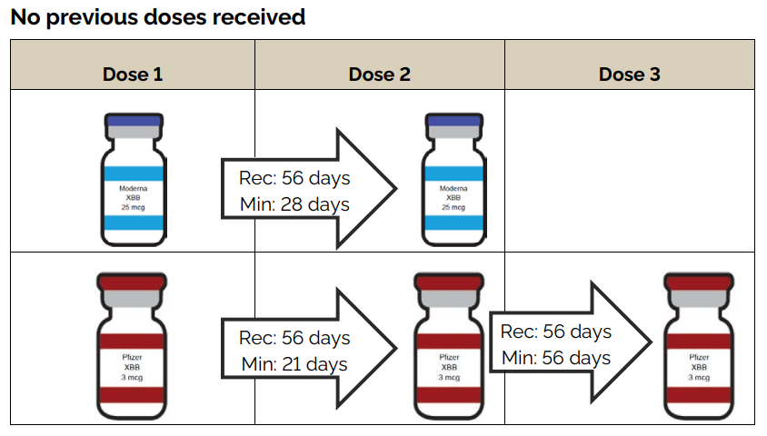
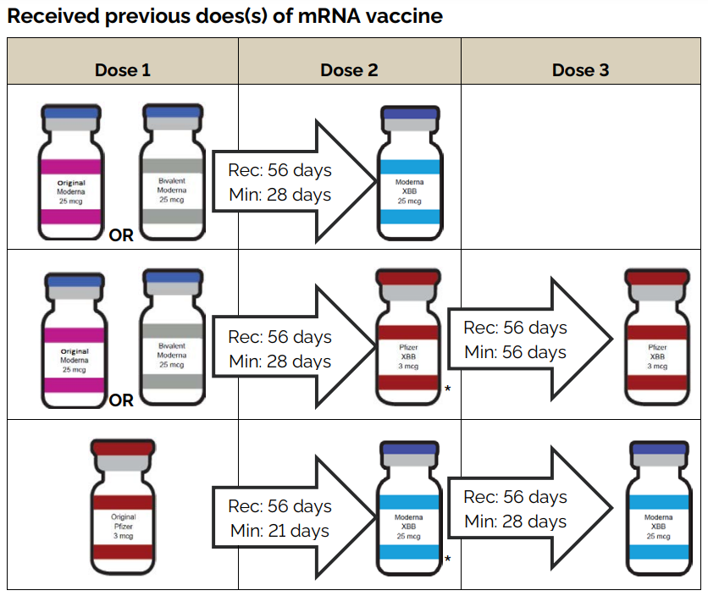
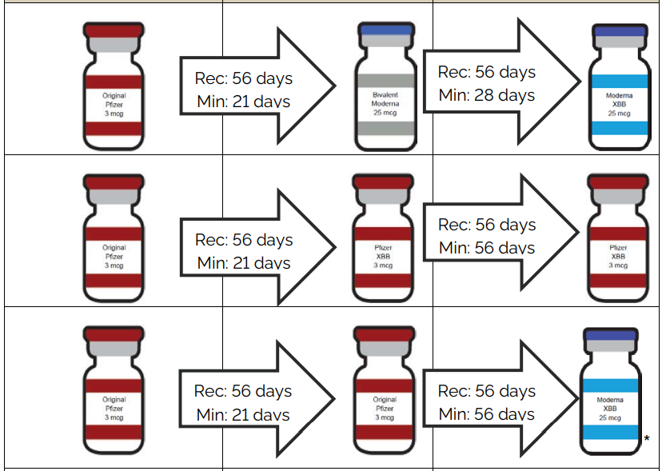
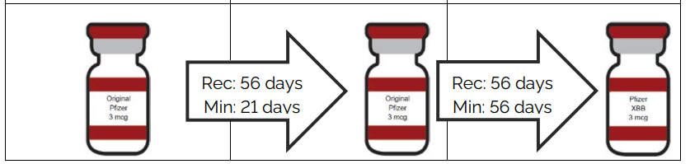
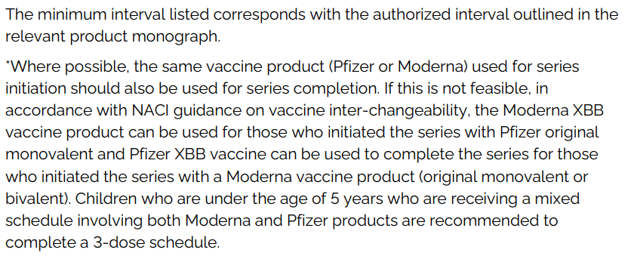
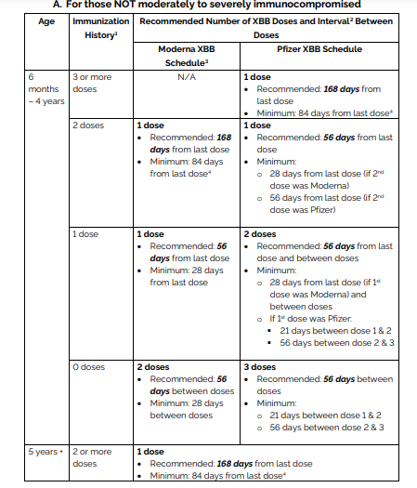
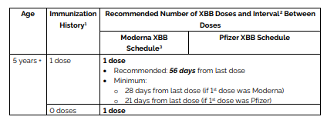
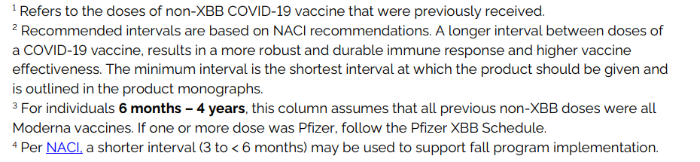
Those who are Severely or Moderately Immunocompromised

The following groups are considered moderately to severely immunocompromised:
- Individuals receiving dialysis (hemodialysis or peritoneal dialysis)
- Individuals receiving active treatment (e.g., chemotherapy, targeted therapies, immunotherapy) for solid tumour or hematologic malignancies
- Recipients of solid-organ transplant and taking immunosuppressive therapy
- Recipients of chimeric antigen receptor (CAR)-T-cell therapy or hematopoietic stem cell transplant (within 2 years of transplantation or taking immunosuppression therapy)
- Individuals with moderate to severe primary immunodeficiency (e.g., DiGeorge syndrome, Wiskott-Aldrich syndrome)
- Individuals with HIV with prior AIDS defining illness or prior CD4 count ≤ 200/mm3 or prior CD4 fraction ≤ 15% or (in children 5-11 years) perinatally acquired HIV infection
- Individuals receiving active treatment with the following categories of immunosuppressive therapies: anti-B cell therapies2 (monoclonal antibodies targeting CD19, CD20 and CD22), high-dose systemic corticosteroids (as per CIG prednisone equivalent of ≥ 2 mg/kg/day or 20 mg/day if weight > 10 kg, for ≥ 14 days), alkylating agents, antimetabolites, or tumor-necrosis factor (TNF) inhibitors and other biologic agents that are significantly immunosuppressive (Appendix A).

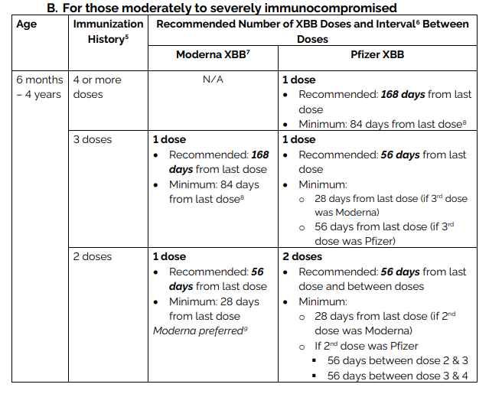
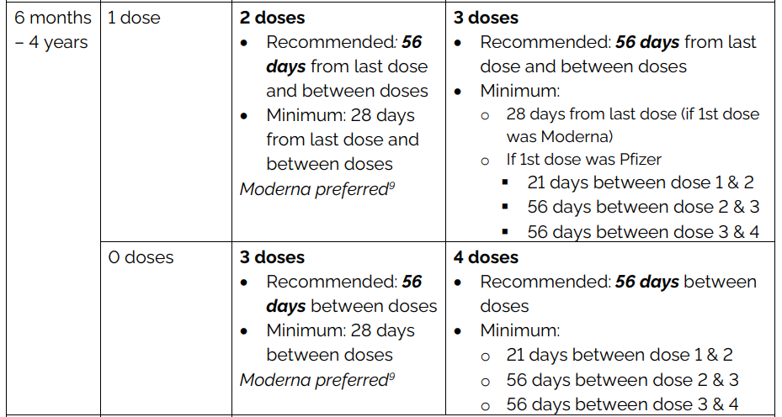
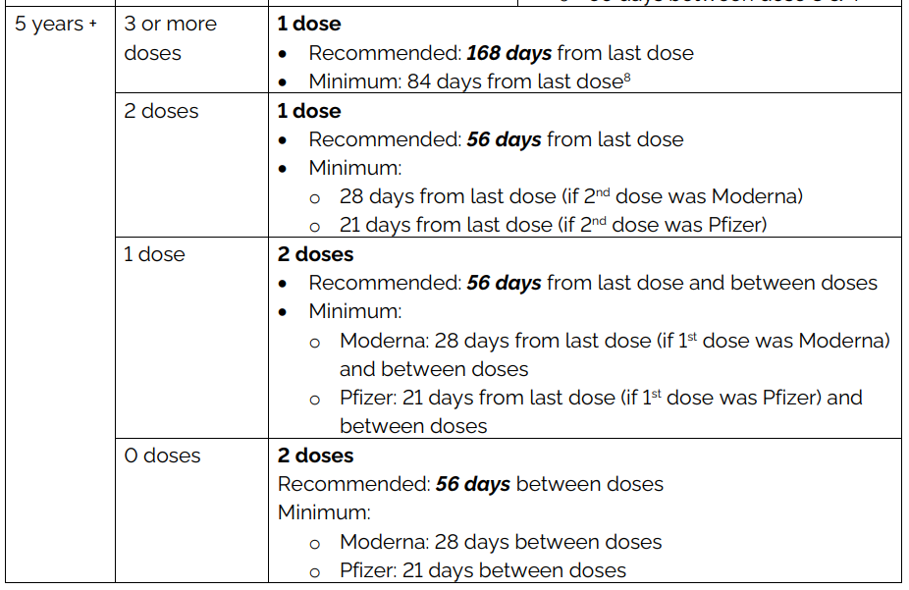
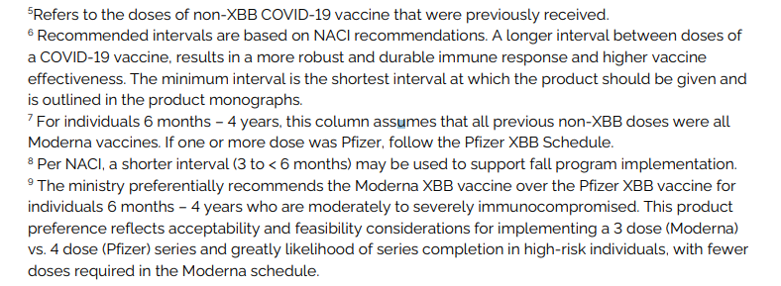

Vaccination in Congregate Settings that are in Outbreak

Any resident or staff of a congregate setting that is in COVID-19 outbreak who is an active COVID-19 case or is symptomatic for COVID-19 should not be vaccinated. Refer to the section above for recommended interval between SARS-CoV-2 infection and vaccination.

Residents and staff that are not active cases and are currently asymptomatic can be vaccinated.

Any resident or staff of a congregate setting that is in enhanced surveillance by public health who is not an active case and is asymptomatic can be vaccinated.

SMDHU staff are not to enter facilities that are in confirmed respiratory outbreak to provide COVID-19 vaccinations to residents. This is to align with the provincial LTC Respiratory outbreak guidance, in which all non-essential activities are to cease during respiratory outbreaks.

Out of Province Vaccination Recommendations

If an individual 5 years of age and older has been vaccinated with one or more non-Health Canada approved vaccine(s), they are recommended to receive a dose of COVID-19 XBB vaccine at a recommended interval of 6 months (minimum 3 months) from their last COVID-19 vaccine or last COVID-19 infection.

Those 6 months – 4 years are recommended to complete either a 2 or 3 dose series (based on whichever product they receive). If the series has been completed with non-Health Canada approved vaccine, they are recommended to receive a COVID-19 XBB vaccine at a recommended interval of 6 months (minimum 3 months) from their last COVID-19 vaccine or last COVID-19 infection. If their 2 or 3 dose series is incomplete, they are recommended to finish their series with a COVID-19 XBB vaccine as per table 1 above.

Use of Bivalent B4/5 mRNA COVID-19 vaccine

Bivalent B4/5 COVID-19 vaccines that were approved by Health Canada last fall are still available should an individual want to receive a dose of this formulation despite the recommendation to receive the new XBB.1.5 formulation. Data from Moderna and Pfizer have shown that the BA.4/5 bivalent vaccines do generate immune responses against the XBB.1.5 variant and variants that are descendants of XBB; however, the new XBB.1.5 vaccine formulation generates a stronger immune response to these more recent variants. If administering Bivalent B4/5 COVID-19 vaccine, use the following schedule and dosing table:

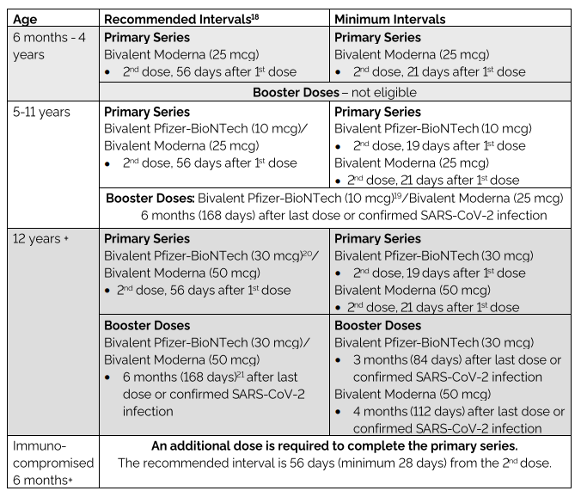

Interval Between Previous SARS-CoV-2 Infection and COVID-19 Vaccination

NACI and the Ministry of Health recommend that COVID-19 vaccines should be offered to individuals with previous SARS-CoV-2 infection without contraindications to the vaccine at the intervals outlined below:

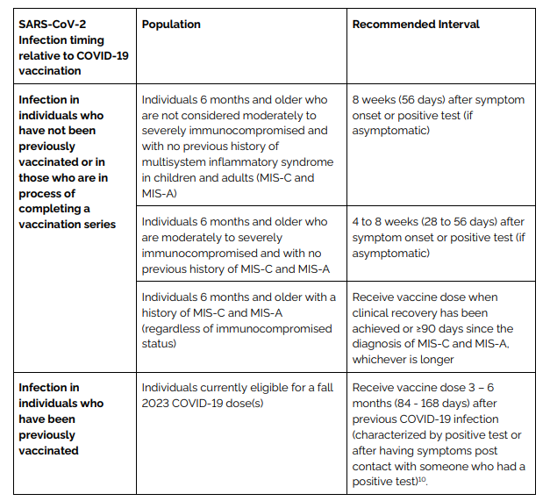

*A previous infection with SARS-CoV-2 is defined as:
- Confirmed SARS-CoV-2 infection using a molecular (e.g., PCR) or Health Canada-approved rapid antigen test; or
- Symptomatic disease compatible with COVID-19 AND a household exposure to a confirmed COVID-19 case

Vaccine Storage and Handling

Nurses will store and handle the vaccine according to the Ministry of Health COVID-19 Vaccine Storage and Handling Guidance, and the manufacturer’s instructions in the product monographs.

mRNA vaccines are fragile, and if not stored, handled and prepared properly the vaccine can breakdown and not be effective. For detailed instructions on preparing each of the vaccines, refer to the product monograph. mRNA are not to be shaken. When preparing the vaccine the swirling hand motion is to be used instead of shaking.

For Pfizer orange cap pediatric, and maroon cap infant products, only the diluent provided from Pfizer is to be used and the diluents are single use and not to be used with more than one vial. Nurses needed to ensure they are drawing the correct amount of diluent for whichever Pfizer product they are preparing as the amounts required are different by product. mRNA vaccines are also sensitive to light and should be stored in their carton or cooler until they are prepared and/or administered.

 | Pfizer 12+  Bivalent B4/5 & XBB Grey Cap & Pfizer XBB Pediatric 5-11 yrs Blue Cap | Pfizer Pediatric 5-11 yrs Bivalent B4/5  Orange Cap | Pfizer Infant XBB Maroon cap | Moderna Bivalent B4/5 & XBB  Royal Blue Cap
Diluent | Not to be diluted | Requires Dilution  Diluent is to be stored between +20C to +25C  It is only to be stored at fridge temp for up to 5 days  Each vial to be diluted with 1.3mL of the provided diluent | Requires Dilution  Diluent is to be stored between +20C to +25C  It is only to be stored at fridge temp for up to 5 days  Each vial to be diluted with 2.2mL of the provided diluent | Not to be diluted
Frozen Vials Prior to use | -90C to -60C for 18 months from date of manufacture  Cannot be stored -25C to -15C |  |  | Can be stored frozen between -50C to -15C until the expiry date.  Do not store below -50ºC
Thawed Unpunctured vials | In fridge at 2-8C for a single period of up to 10 weeks within the 18-month shelf-life.  Do not refreeze thawed vials |  |  | In fridge at 2-8C for up to 30 days prior to first use  Vials may be stored between +8C to +25C for up to 24 hours
Thawed Punctured vials | After first puncture, store between +2C to +25C  Use within 12 hours after first puncture |  |  | After the first dose has been withdrawn the vial should be held between +2C to +25C  Use within 24 hours after first puncture
Thawing | Allow vial to thaw in fridge at 2-8C.  A carton of 10 vials may take up to 6 hours to thaw.  Vials may thaw at room temperature (up to +25C) for 30 minutes. | Allow vial to thaw in fridge at 2-8C.  A carton of 10 vials may take up to 4 hours to thaw.  Vials may thaw at room temperature (up to +25C) for 30 minutes. | Allow vial to thaw in fridge at 2-8C.  A carton of 10 vials may take up to 2 hours to thaw.  Vials may thaw at room temperature (up to +25C) for 30 minutes. | Thaw in fridge at 2-8C for 2 hours  Thaw at room temp for 45 mins  After thawing, let vials sit at room temperature for 15 minutes before administering.
Syringe Stability | Only stable in syringe for 12 hrs. |  |  | Stable in syringe no later than the 24 hours after the vial was first puncture.

It is recommended that vaccine is transported in a syringe once a vial has been punctured, as the air pressure in the vial will have been changed and the potential for agitation (physical stress) of the mRNA is more likely.

It is recommended that if an additional dose(s) of vaccine can be withdrawn from a single vial that it is administered as a valid dose and recorded accordingly (i.e. you can extract an 11th dose from a 10 dose vial). Pooling of vaccine from more than one vial to make a full dose is not permitted.

Contraindications

- Those who have had severe allergic reaction or anaphylaxis to a previous dose of COVID-19 mRNA vaccine or to any of its components (polyethylene glycol and, due to potential cross-reactivity, polysorbate) should not receive the mRNA COVID-19 vaccine in a community-based vaccine clinic. These people need an urgent referral to an allergist or immunologist to determine how/if they will complete their series.

Those with a suspected history of adverse reactions to tromethamine (Tris, trometamol), including those with a suspected history of systemic allergic reactions to radio contrast media (RCM) and ketorolac, may receive vaccines containing tromethamine with informed consent that the risk of adverse systemic reactions to this compound is extremely low, with an extended post-vaccination observation time of 30 minutes.

For those who have had an allergic reaction within 4 hours and/or anaphylaxis that occurred with a vaccine or injectable medication that does not contain a component or cross-reacting component of mRNA COVID-19 vaccines, the vaccine can be given with an extended post-vaccination observation time of 30 minutes.

Those with a history of significant allergic reaction and/or anaphylaxis to any food, drug, venom, latex or other allergens not related to the mRNA COVID-19 vaccine can receive the vaccine with an extended post-vaccination observation time of 30 minutes.

- COVID-19 mRNA vaccines are contraindicated in those with an allergy to any component of the vaccine or an anaphylactic or other allergic reaction to a previous dose of this vaccine:

Vaccine | Vaccine Components | Contains Latex (Yes or No)
Moderna XBB.1.5 COVID-19 vaccine formulation | - Dispersion, (0.10 mg /mL) Andusomeran (mRNA) encoding the pre-fusion stabilized conformation variant (K982P and V983P) of the SARS-CoV-2 Spike glycoprotein (Omicron subvariant XBB.1.5)  - Acetic acid  - Cholesterol  - DSPC (1,2-distearoyl-sn-glycero-3-  phosphocholine)  - Lipid SM-102  - PEG2000-DMG (1,2-dimyristoyl-racglycerol,methoxy-polyethyleneglycol)  - Sodium acetate trihydrate  - Sucrose  - Trometamol  - Trometamol hydrochloride  - Water for injection | No
Pfizer XBB.1.5  COVID-19  vaccine formulation | - Suspension - Raxtozinameran (mRNA) encodes for the viral spike (S) protein of SARS-CoV-2 Omicron XBB.1.5 strain  - ALC-0315 = ((4-hydroxybutyl) azanediyl)bis (hexane-6,1-diyl)bis(2-  hexyldecanoate)  - ALC-0159 = 2-[(polyethylene glycol)-2000]-N,N-ditetradecylacetamide  - Cholesterol  - DSPC = 1,2-distearoyl-sn-glycero-3-  Phosphocholine  - sucrose  - tromethamine  - tromethamine hydrochloride  - water for injection | No
Pfizer-BioNTech Bivalent COVID-19 vaccine formulation  Dark grey cap 0.3 mL (30 mcg) | - Suspension - Tozinameran (mRNA) encodes for the viral spike (S) protein of SARS-CoV-2 Original strain and famtozinameran (mRNA) encodes for the viral spike (S) protein of SARS-CoV-2 Omicron BA.4/BA.5 strain  - ALC-0315 = ((4-hydroxybutyl) azanediyl)bis (hexane-6,1-diyl)bis(2- hexyldecanoate)  - ALC-0159 = 2-[(polyethylene glycol)- 2000]-N,N-ditetradecylacetamide  - 1,2-distearoyl-sn-glycero-3- phosphocholine  - cholesterol  - sodium chloride  - sucrose  - tromethamine  - tromethamine hydrochloride  - water for injection | No
Pfizer-BioNTech Bivalent COVID-19 Vaccine – Pediatric  Orange cap 0.2mL  (10 mcg) | - Suspension - Tozinameran (mRNA) encodes for the viral spike (S) protein of SARS-CoV-2 Original strain and famtozinameran (mRNA) encodes for the viral spike (S) protein of SARS-CoV-2 Omicron BA.4/BA.5 strain  - ALC-0315 = ((4-hydroxybutyl) azanediyl)bis (hexane-6,1-diyl)bis(2- hexyldecanoate)  - ALC-0159 = 2-[(polyethylene glycol)- 2000]-N,N-ditetradecylacetamide  - 1,2-distearoyl-sn-glycero-3- phosphocholine  - cholesterol  - sodium chloride  - sucrose  - tromethamine  - tromethamine hydrochloride  - water for injection
Moderna Bivalent BA4/5 COVID-19 Vaccine formulation  (Royal blue cap with grey label) | - Dispersion, (0.10 mg /mL)  Elasomeran (mRNA) encoding the pre-fusion stabilized Spike glycoprotein of 2019 novel Coronavirus (SARS-CoV-2), and davesomeran (mRNA) encoding the pre-fusion stabilized conformation variant (K983P and V984P) of the SARS-CoV-2 Spike glycoprotein (Omicron variant B.1.1.529 [BA.1])  - Acetic acid  - Cholesterol  - DSPC (1,2-distearoyl-sn-glycero-3-  phosphocholine)  - Lipid SM-102  - PEG2000-DMG (1,2-dimyristoyl-rac-glycerol,methoxy-polyethyleneglycol)  - Sodium acetate trihydrate  - Sucrose  - Trometamol  - Trometamol hydrochloride  - Water for injection | No

- COVID-19 mRNA vaccine should only be administered in SMDHU clinics to the following groups if they have consulted with their treating physician and it has been determined that the potential benefits of vaccination outweigh the potential risks:
- Those who are receiving the following immunosuppressive therapies: stem cell therapy, CAR-T therapy, chemotherapy, immune checkpoint inhibitors, monoclonal antibodies (e.g. rituximab) and other targeted agents (e.g., CD4/6 inhibitors, PARP inhibitors etc.)

- As a precautionary measure until more information is available, further doses of mRNA COVID-19 vaccines should be deferred among individuals who have experienced myocarditis (with or without pericarditis) within 6 weeks of a previous dose of an mRNA COVID-19 vaccine in most cases. This includes any person who had an abnormal cardiac investigation including electrocardiogram (ECG), elevated troponins, echocardiogram, or cardiac MRI after a dose of an mRNA vaccine.

Those with a history compatible with pericarditis and who either had no cardiac workup or had normal cardiac investigations, can be revaccinated once they are symptom free and at least 90 days has passed since vaccination. MOH consultation can be considered if patient history is unclear.

Some people with confirmed myocarditis (with or without pericarditis) may choose to receive another dose of vaccine after discussing the risks and benefits with their healthcare provider. If another dose of vaccine is offered, they should be offered the Pfizer-BioNTech 30 mcg vaccine due to the lower reported rate of myocarditis and/or pericarditis following the Pfizer-BioNTech 30mcg vaccine compared to the Moderna 100 mcg vaccine. Informed consent should include discussion about the unknown risk of recurrence of myocarditis and/or pericarditis following receipt of additional doses of Pfizer-BioNTech COVID-19 vaccine in individuals with a history of confirmed myocarditis and/or pericarditis after a previous dose of mRNA COVID-19 vaccine, as well as the need to seek immediate medical assessment and care should symptoms develop. For these individuals, documentation from the treating physician supporting revaccination must be provided to clinic staff.

- Individuals with a current or recent history of unexplained chest pain or shortness of breath (SOB), or chest pain/SOB not previously investigated by their HCP, should have vaccination deferred. They should be referred to their HCP for follow up, or if symptoms are severe they should be directed to the emergency department/911.

- For children who have been diagnosed with Multisystem Inflammatory Syndrome (MIS), vaccination is to be postponed until recovered or ≥90 days since diagnosis, whichever is longer.

In general, if a patient is 3 months post-chemotherapy and the cancer is in remission, or if immunosuppressive therapy has been discontinued for at least 3 months (6 months or more for anti-B cell antibodies), the person is no longer considered immunocompromised.

People living with HIV that are considered immunocompetent may be vaccinated. Those with stable Hep B and Hep C virus may also be vaccinated.
Pregnant and Breastfeeding Individuals

COVID-19 vaccination during pregnancy is effective at protecting against severe COVID-19 disease, hospitalization, and ICU admission from COVID-19 infection, as well as intubation and maternal mortality in those with severe disease. Pregnant or breastfeeding individuals should receive all recommended COVID-19 vaccine doses as soon as they are able.

Recommendations for vaccination during pregnancy and/or breastfeeding:
- A COVID-19 booster may be offered at any stage of the pregnancy (i.e., in any trimester).
- A minimum interval of 6 months from the previous COVID-19 vaccine dose or SARS-CoV-2 infection is recommended.
- COVID-19 vaccines may be co-administered with other vaccines recommended during pregnancy or while breastfeeding.
- NACI strongly recommends that individuals who are pregnant or breastfeeding who have not yet begun or completed the primary series should be offered the recommended doses to complete the primary series.

Persons with Autoimmune Conditions and Immunocompromised Persons (due to disease or treatment)

While those receiving the severely immunosuppressive treatments outlined in contraindication #3 must speak with their treating HCP prior to vaccination, all other individuals with autoimmune conditions, immunodeficiency conditions or those immunosuppressed due to disease or treatment should be offered the vaccine. These individuals may choose to consult with their health care provider prior to vaccination (for example, to discuss immunosuppressive medication management/timing in relation to their vaccination).

Precautions and Other Important Information

- Individuals 6 months and older, may receive a COVID-19 vaccine simultaneously with (i.e., same day), or at any time before or after non-COVID-19 vaccines (including live and non-live vaccines). If vaccines are co-administered, immunization on separate limbs is recommended, however if the same limb must be used, the injection sites should be separated by at least 2.5 cm (1 inch). There are two exceptions. COVID-19 vaccines should not be co-administered with the Imvamune vaccine (for mpox) and the Arexvy vaccine for Respiratory Syncytial Virus (RSV).

Imvamune: if vaccine timing can be planned, it is recommended to wait at least 4 weeks before or after administration of an Imvamune vaccine. However, the administration of Imvamune as pre- or post-exposure vaccination should not be delayed in an individual who has recently received a COVID-19 vaccine. These suggested waiting periods are precautionary and may help prevent erroneous attribution of an AEFI to one particular vaccine or the other.

Arexvy: it is recommended to wait at least 2 weeks before or after administration of the RSV vaccine.

- There is a theoretical risk that mRNA or viral vector vaccines could temporarily affect cell-mediated immunity, resulting in false-negative TST or IGRA test results. However, there is no direct evidence for this interaction. Therefore, in the absence of data and acknowledging the importance of both timely tuberculosis testing and immunization, vaccination with COVID-19 vaccines may take place at any time before, after or at the same visit as the TST or IGRA test. Repeat tuberculin skin testing or IGRA (at least 4 weeks post-COVID-19 immunization) of individuals with negative TST or IGRA results for whom there is high suspicion of latent tuberculosis infection may be considered in order to avoid missing persons with TB infection.

- COVID-19 vaccines should not be given concurrently with anti-SARS-CoV-2 monoclonal antibodies. Administration of these products concurrently may result in decreased effectiveness of the COVID-19 vaccine and/or anti-SARS-CoV-2 monoclonal antibodies. Anti-SARS-CoV-2 monoclonal antibodies have high affinity for the spike protein expressed by COVID-19 vaccines, which could prevent the production of antibodies stimulated by the vaccine,or binding of vaccine antigen to the monoclonal antibody may neutralize the antibody. Timing of administration of COVID-19 vaccines following administration of therapeutic or post-exposure anti-SARS-CoV-2 monoclonal antibodies should be assessed in consultation with clinical experts on a case-by-case basis.

- People who are offered an mRNA COVID-19 vaccine should be informed of the very rare risk of myocarditis and/or pericarditis following immunization and should be advised to seek immediate medical attention if they develop symptoms, which may include chest pain, shortness of breath, or the feeling of a fast, pounding, or fluttering heartbeat. Cases typically occur within a week after the receipt of an mRNA vaccine dose, more commonly after a second dose. Any potential cases should be investigated with medical assessment regardless of timing from vaccination to onset.

- Re-vaccination with a new COVID-19 vaccine primary series is recommended post-transplantation for hematopoietic stem cell transplant (HSCT), hematopoietic cell transplants (HCT) (autologous or allogeneic), and recipients of CAR-T-cell therapy given the loss of immunity following therapy or transplant. Optimal timing for re-immunization should be determined on a case-by-case basis in consultation with the client’s specialist, and the client needs to provide written documentation from their specialist to clinic staff.

Quality Assurance

The program managers will ensure that:
- The directive is reviewed and updated as needed.
- Nurses are provided a comprehensive orientation program, including a review of all relevant resources as outlined below.
- A current list of nurses who have received directive training is maintained.
- All medication errors are reviewed as per agency policy.

References

Product Monograph for COMIRNATY® XBB.1.5 COVID-19 Vaccine, September 28, 2023

Product Monograph for SPIKEVAX® XBB.1.5 COVID-19 Vaccine, September 12, 2023

Product Monograph for COMIRNATY® Original & Omicron BA.4/BA.5 COVID mRNA Bivalent Vaccine, September 13, 2023.

Product Monograph for SPIKEVAX® Bivalent (Original/Omicron) [COVID-19 mRNA vaccine, Bivalent (Original and Omicron BA.4/5 Variant)], November 3, 2022.

Canadian Society of Allergy and Clinical Immunology. SARS-CoV-2 Vaccines & Tromethamine:
Guidance for Allergists/Immunologists from the CSACI. January 15, 2023.

Canadian Immunization Guide: COVID-19 vaccine Chapter

Ontario Ministry of Health. COVID-19 Vaccine Guidance – Revised October 6, 2023

Ontario Ministry of Health. COVID-19 Vaccine Storage and Handling Guidance – Revised October 6, 2022

SMDHU Policy LG0101 – Consent for Treatment – Revised September 2010

SMDHU Policy LG0104 – Delegated Controlled Acts – Revised August 25, 2010

SMDHU Policy GEN0105 – Directives & Standing Orders – Revised August 25, 2010

College of Nurses of Ontario (CNO), Practice Guideline, 41019, Directives. Updated June 2020. https://www.cno.org/globalassets/docs/prac/41019_medicaldirectives.pdf

CNO, Practice Standard, 41007, Medication. Updated June 2022.
http://www.cno.org/docs/prac/41007_Medication.pdf

CNO, Practice Standard, 41071, Decisions about Procedures and Authorities, Revised January 2020.
https://www.cno.org/globalassets/docs/prac/41071_decisions.pdf

The College of Physicians and Surgeons Policy #5-12 – Delegation of Controlled Acts. Revised March 2021
https://www.cpso.on.ca/Physicians/Policies-Guidance/Policies/Delegation-of-Controlled-Acts

Educational Resources

- Ministry of Health COVID-19 Vaccine Guidance
- Ministry of Health COVID-19 Vaccine Storage and Handling Guidance
- Immunization Program Guidebook
- Canadian Immunization Guide, Evergreen Edition
http://www.phac-aspc.gc.ca/publicat/cig-gci/index-eng.php

Authorized to

All (insert staff’s designation) employed by (insert organization name), who have received the directive training and who have the following qualifications are authorized to administer these vaccines:

- Registered Nurses and Registered Nurses (temporary) listed as a member with the College of Nurses of Ontario with no restrictions or limitations on their registration.
- Registered Practical Nurses and Registered Practical Nurses (temporary) listed as a member with the College of Nurses of Ontario with no restrictions or limitations on their registration. Registered Practical Nurses that were registered with the College of Nurses prior to 2005 must also have an advanced medication course certificate.
- Current CPR certification Level C (updated annually).

Authorization and Approval

The steps outlined in this directive, and training and resources available provide staff with the necessary knowledge and skills to safely, effectively and ethically administer this vaccine in a clinic setting.

Authorization and Approval

The steps outlined in this directive, and training and resources available provide staff with the necessary knowledge and skills to safely, effectively and ethically administer this vaccine in a clinic setting.

Review/Revision History

