Community Clinic Screener role
- Prior to clinic:
- Bring clean googles/ face shield
- Bring identification
- Confirm clinic location, start time, coordinator contact information

- Clinic set up:
- Help set up clinics by cleaning and distributing supplies
- Check in with coordinator, introductions, and plan for day (huddle)
- Ensure you have the supplies needed in the screening area (masks, hand sanitizer, screening questions)
- Screeners are to be in full PPE at all times (gown, gloves, medical mask and eye protection)

- During Clinic: Aftercare:
  - Greet people as they arrive at the clinic.
  - If client is not wearing a face covering inform them it is required for all clients, have them use hand sanitizer and then remove one from the stand. If the client indicates they are unable to wear one due to medical, cultural or religious reasons or other reasons, do not insist they wear one, thank them for letting you know.
  - Confirm the client has an appointment
  - Inform client you need to ask them screening questions before they can proceed into the clinic area.
  - Actively screen clients for symptoms or risk factors for COVID-19 infection.
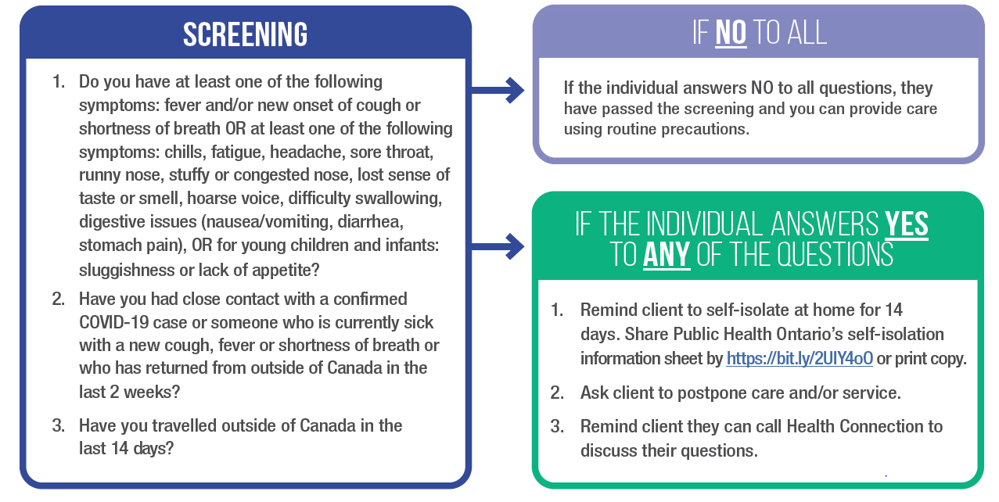

- If the client says no to all questions please ask them to sanitize their hands with alcohol based hand rub and direct them to the check in area.
- If the client says yes to any questions inform them that they have screened positive of possible symptoms or exposure to COVID-19 they should return home and self-isolate and seek further assessment at the local assessment centre.

- At the end of clinic:
- Clean up area- tables & chairs wiped
- Clean and sign iPads back in if used
- All sharps bins locked and in specific room
- IPAC procedures for cleansing goggles, computers, cellphones and any other personal items at clinic
- Support with packing of supplies

