How to Generate an Email Receipt for Client in COVaxon
- Locate the client record in COVaxon
- On the right hand side click on the DA-#### (for the dose you want the receipt for) under the dose administration box.
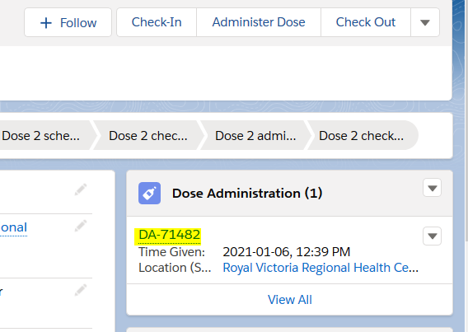
- Once you select the DA-#### a the top right of the screen again you will see a Generate Receipt Button. Click on it.
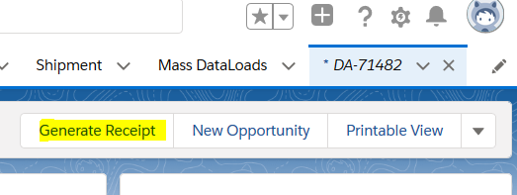
- Check the box beside Email receipt to patient and click Next. This will automatically trigger the system to email the receipt to the email in the clients file.
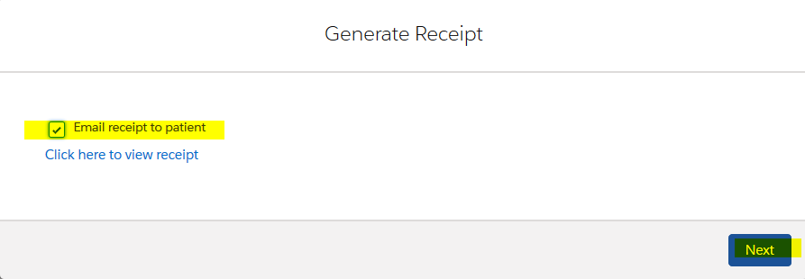

Note: If you don’t see the email receipt option it means there is either:
- No email in the clients profile or
- Consent to send emails has not been selected.
In this situation you need to go back to the client’s profile (click on the client’s name which will bring you back to the client details page) and make the changes there.
