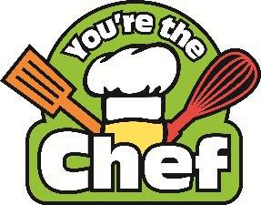

CERTIFICATE OF COMPLETION

This certificate of completion is awarded to

(Name of Participant)

for successfully completing the You’re the Chef program at (add school name)

(Date)

School Admin/ YTC leader School Admin/YTC leader

