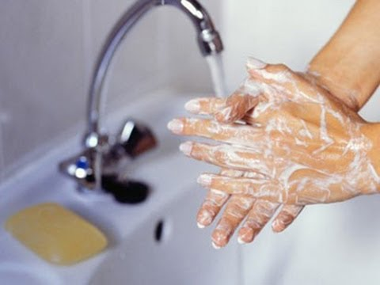
Ways to Stay Healthy During the Flu Season

- Get your flu shot. It will protect you, as well as your family and friends.
- Wash your hands often with soap and water or a hand sanitizer that contains alcohol.
- Cough and sneeze into a tissue or your arm, not your hand.
- Stay at home if you are sick, and avoid contact with people who are sick with the flu.
Clean surfaces often (for example, counter tops, keyboards and telephones). Flu viruses can live on surfaces for up to eight hours.
What if you get the flu?
If you get the flu, take these steps to speed up your recovery and to prevent sharing the "bug" with others:
- Stay home from work or school when you are sick
- Keep surfaces clean
- Sneeze or cough into a tissue or sleeve, not your hands
- Dispose of tissues immediately after use
- Wash your hands often
- Get lots of rest
- Treat fever and cough
- Drink plenty of fluids
- Don't be a visitor in a hospital, or a long-term care facility
- Avoid close contact with infants, pregnant women, and people over the age of 65, and those with chronic health problems. Anyone in these groups can catch the flu easily.

