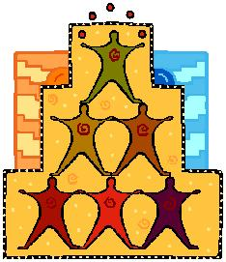
Sample Evaluation Chart

What is Working? | What Needs to be Improved? | What Needs to be Done? | Who Will Take Responsibility? | Date of Expected Resolution?

