Links to Ontario Public Health Units Strategic Plans and/or Mission, Vision and Values
Created by: D. Hardwick April 26, 2011

Algoma http://www.algomapublichealth.com/default.aspx?l=,1,2,4

Chatham Kent
http://www.chatham-kent.ca/NR/rdonlyres/B385214C-A644-404E-A522-9FAD48714D03/5896/CSPMasterrevisedJAN08.pdf

Durham Region http://www.durham.ca/corpoverview/communityplan/CSPFinalColour.pdf

Eastern Ontario http://www.eohu.ca/_files/resources/resource1296.pdf

Elgin St Thomas http://elginhealth.on.ca/index.asp?ParentID=15&MenuID=301

Grey Bruce http://www.publichealthgreybruce.on.ca/HOME/Misc/AboutUs.htm

Haldimand-Norfolk http://www.hnhu.org/images/stories/reports/strategic_plan_mission-vision_statement_final.pdf

Hamilton Public Health
http://www.hamilton.ca/NR/rdonlyres/DE97327C-3385-40B4-953C-45FBE064C667/0/PublicHealthStratPlan.pdf

Kingston, Frontenac, Lennox & Addington
http://kflapublichealth.ca/files/static/Strategic_Plan.pdf

Leeds Grenville
http://www.healthunit.org/reportpub/strategic/strategic_plan2006-2010_final_report-revised_April_13-06.pdf

Niagara Region
http://www.niagararegion.ca/government/council/agendas-minutes/Pdf/COM04-2009.pdf

North Western Health Unit
http://www.nwhu.on.ca/about/hur-strategic-plans.php

Peel Region
http://www.peelregion.ca/health/health-status-report/stay-ahead-curve/pdfs/full-report.pdf

Perth District Health Unit http://www.pdhu.on.ca/view.php?public/About_Us/Strategic_Plan

Peterborough City County Health Unit
http://pcchu.peterborough.on.ca/Plans/Strategic-Plan/StrategicPlan.pdf
Sudbury District Health Unit
http://www.sdhu.com/SDHU_Stra_Plan-BRO_PDFVERSION_ENG.pdf

Thunder Bay http://www.tbdhu.com/board/BOHMissionValues.htm

Timiskaming Health Unit http://www.timiskaminghu.com/uploads/files/AnnualReports/THU%20Annual%20Report%202009-FINAL.pdf

Toronto Public Health
http://www.toronto.ca/health/strategicplan/pdf/tph_strategic_plan_2010_2014.pdf

Wellington-Dufferin-Guelph
http://www.wdghu.org/CMSPDF/2005StrategicPlan.pdf?CFID=2084065&CFTOKEN=51558756
http://www.wdghu.org/page.cfm?id=2317

Selected Vision and Mission Statements

Haldimand Norfolk
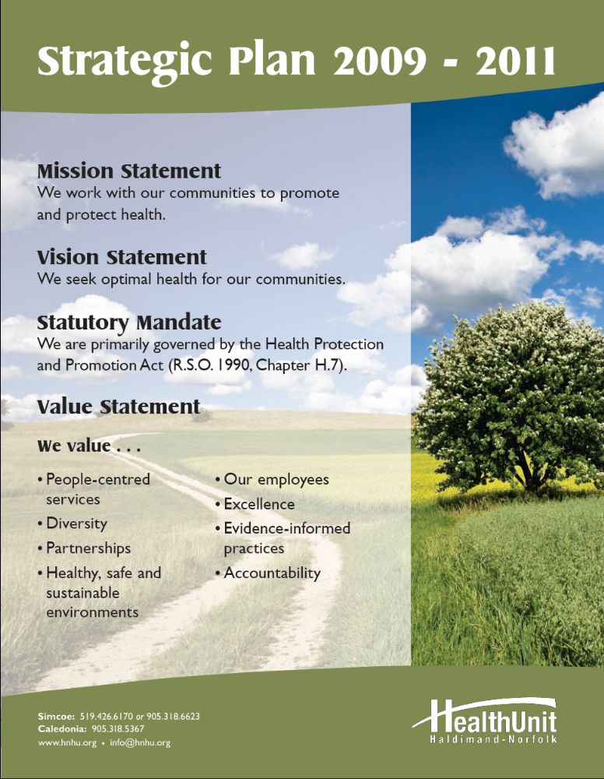
Hamilton Public Health Services
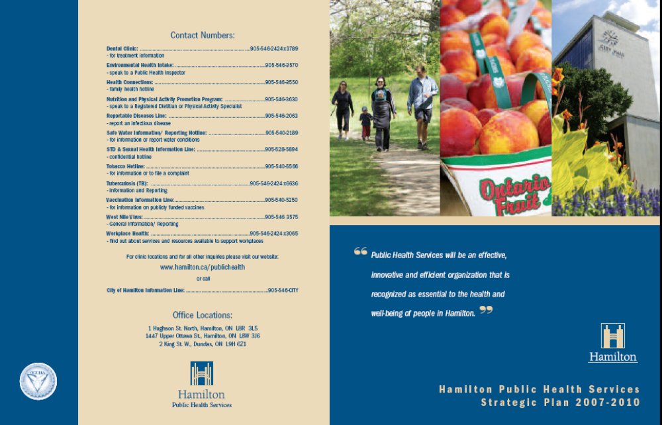

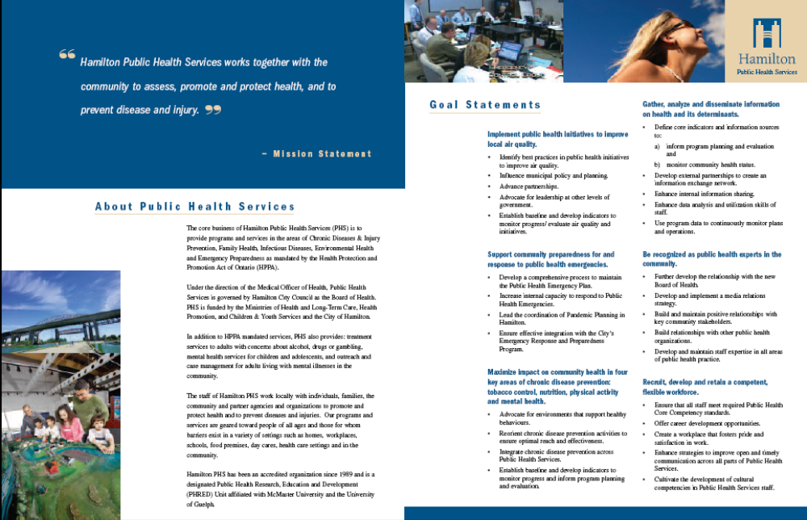
Kingston Frontenac Lennox & Addington
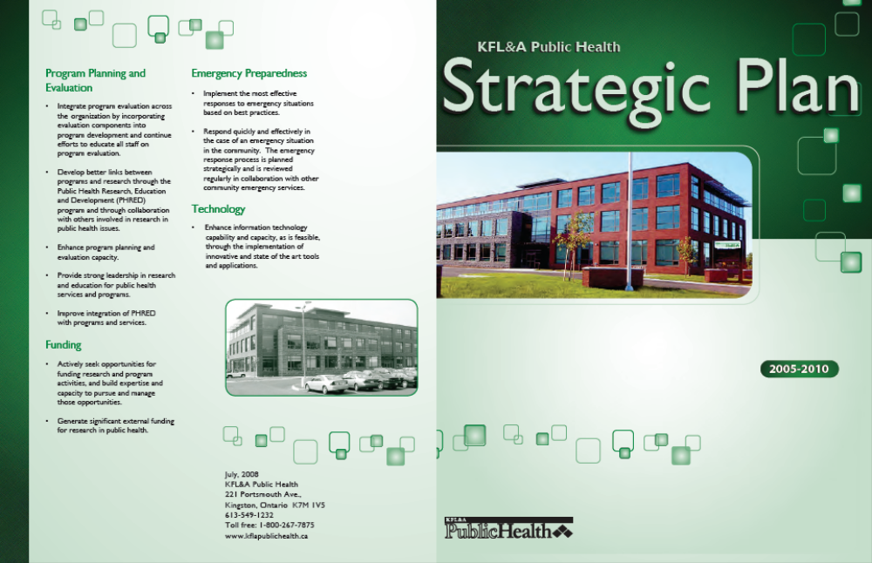

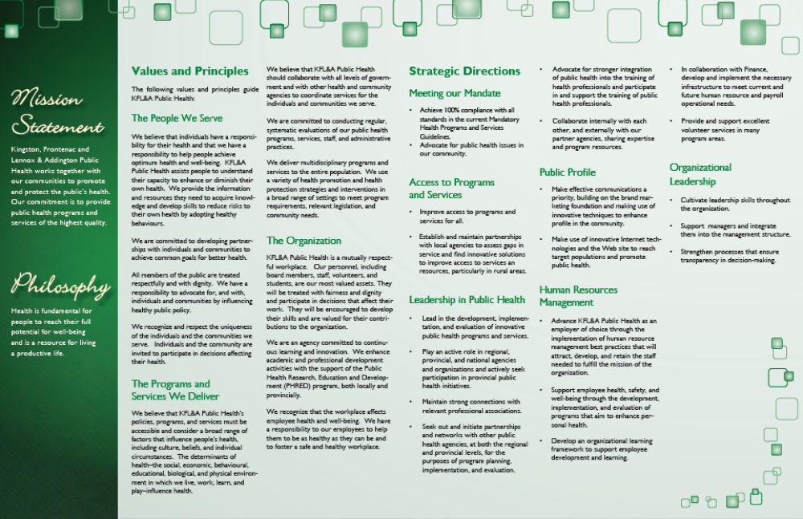
Leeds, Grenville & Lanark
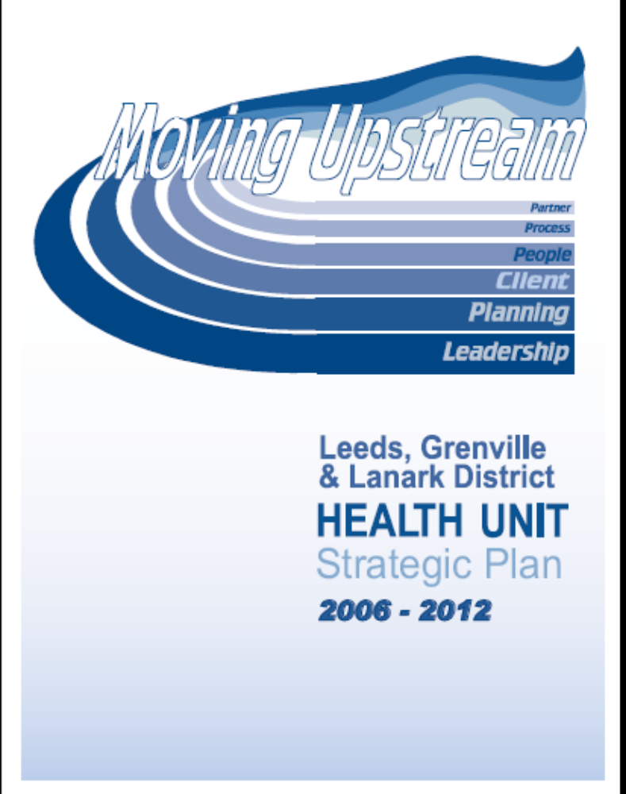
Northwestern Health Unit
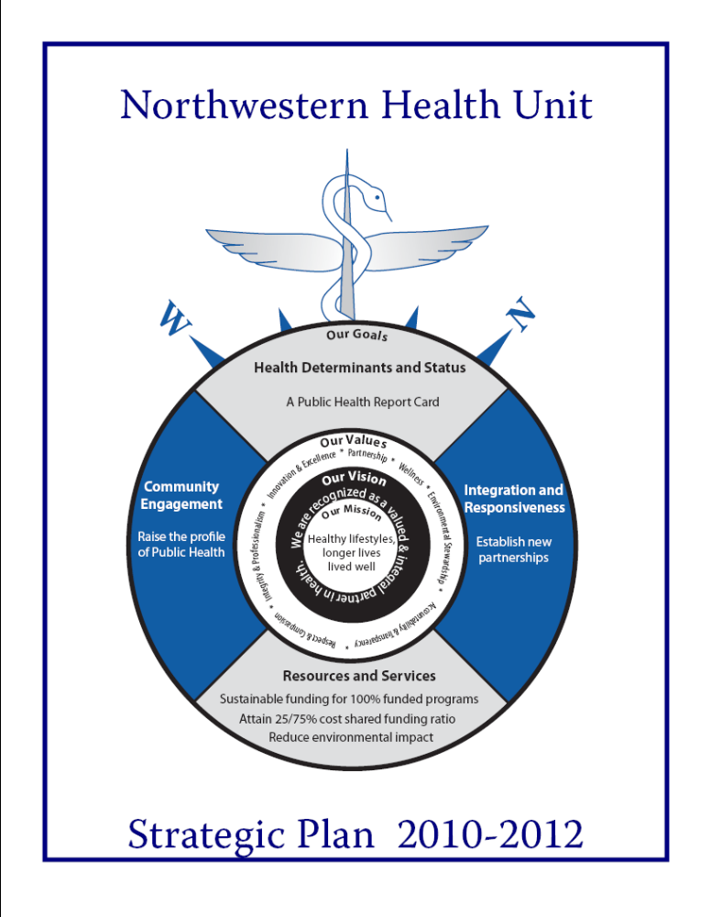
Peterborough City County Health Unit

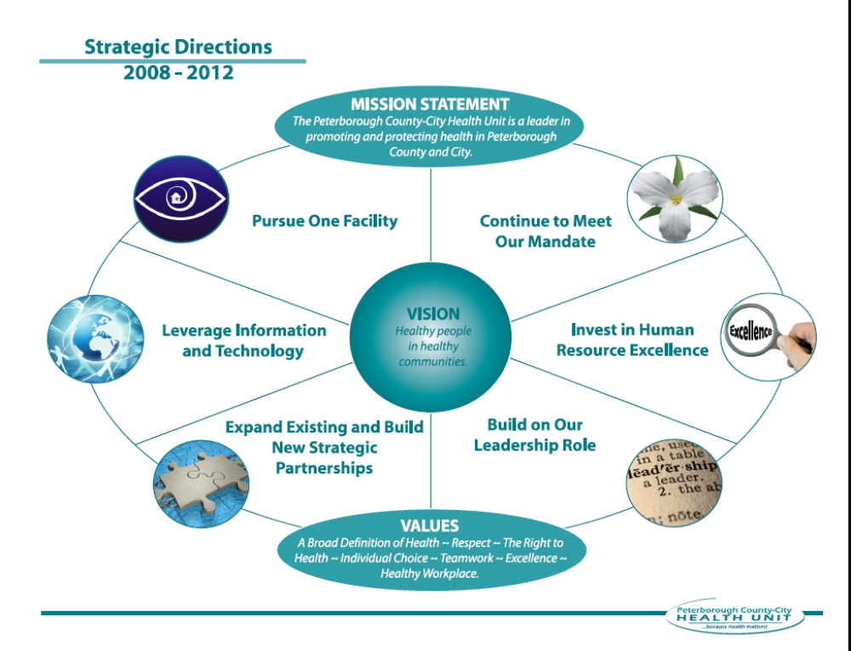

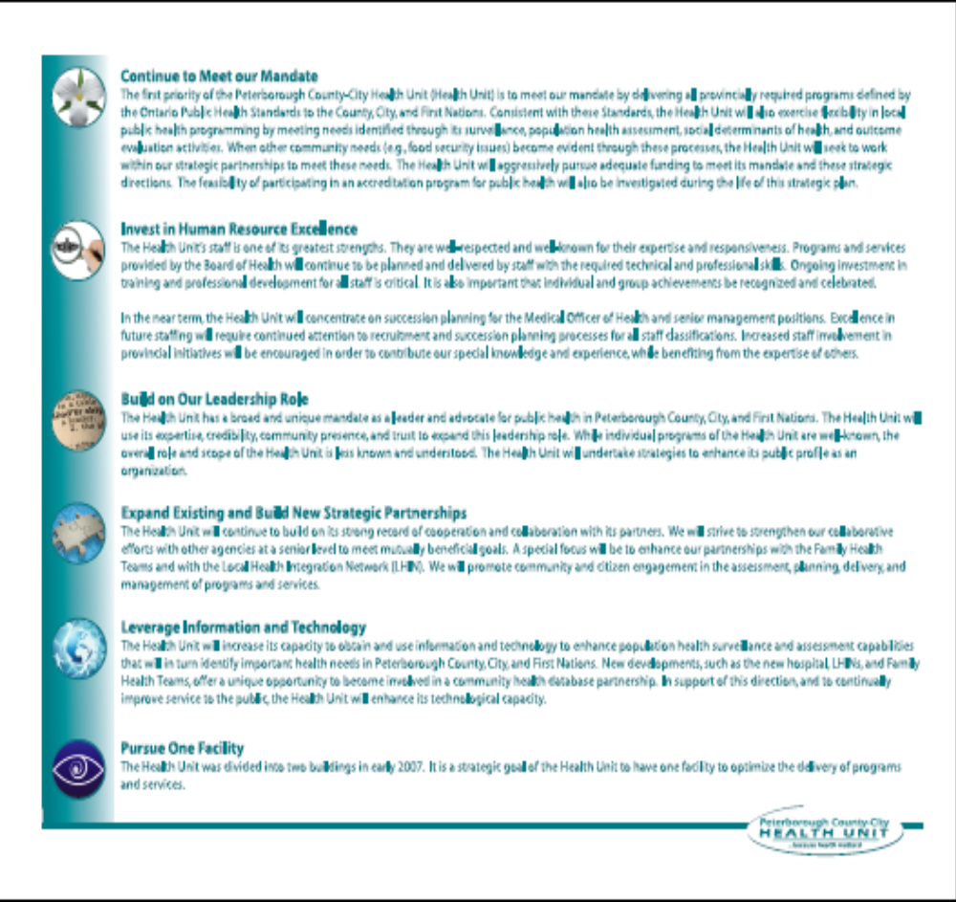
Sudbury & District Health Unit
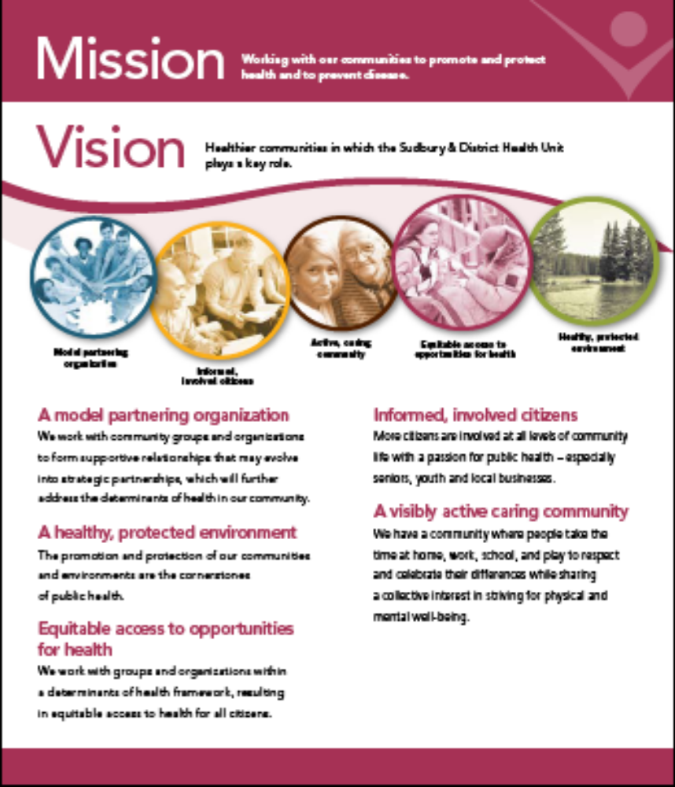
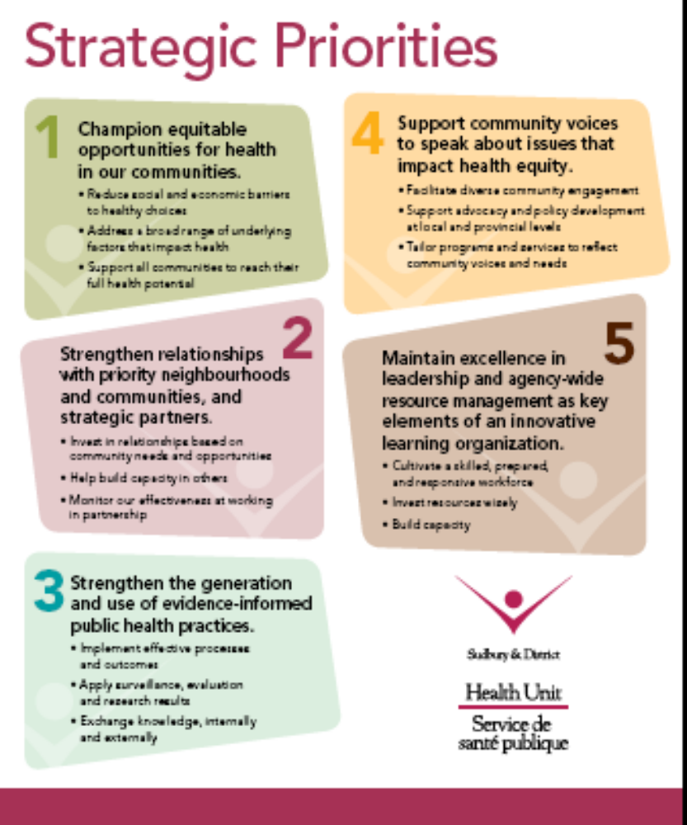
Toronto Public Health


