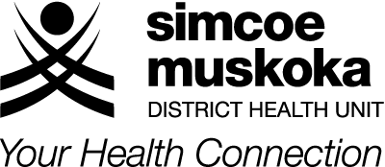
ORAL HEALTH SERVICE
Barrie by the Bay, 403-80 Bradford Street
Barrie, Ontario, L4N 6S7
TEL: 705-721-7520 FAX: 705-734-9369
Toll Free: 1-877-721-7520
www.simcoemuskokahealth.org

ONTARIO WORKS DENTAL PROGRAMS

CRITERIA FOR THE EXTRACTION OF THIRD MOLARS

The prophylactic extraction of third molars is not covered by the Ontario Works Adult Dental Program administered by the Simcoe Muskoka District Health Unit. To help clarify the coverage provided by the program with respect to the extraction of third molars, the following criteria have been established.

Although evidence based, the following criteria are for the purpose of administration of the programs identified above and are not meant to represent a standard of practice.

Criteria for coverage under the Ontario Works Adult Dental Program for the removal of third molars:

► If partially erupted
- Advance dental decay
- Repeated pericoronitis

► If completely covered by bone
- Disease of the follicle including cysts, tumours etc.
- Internal/external resorption of the tooth or adjacent tooth

When submitting a claim or a predetermination for the extraction of one or more third molars, please indicate, for each tooth, the applicable criteria.

(Listing the applicable number 1 – 4 is acceptable.)

Client’s Name: __________________________________________________________

Dentist’s Signature: __________________________________________________________

Tooth # | Criteria 1, 2, 3, 4
18
28
38
48

Thank you for your co-operation.

