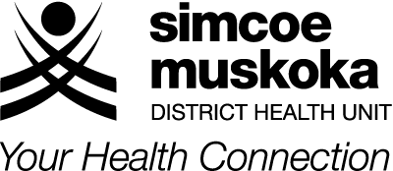
ORAL HEALTH SERVICE
Barrie by the Bay, 403-80 Bradford Street
Barrie, ON L4N 6S7
TEL: 705-721-7520 FAX: 705-734-9369
Toll Free: 1-877-721-7520
www.simcoemuskokahealth.org

ORAL HEALTH SERVICE

ONTARIO WORKS – ENDODONTIC COVERAGE

(Please answer all questions. Incomplete forms will be returned.)

Client’s Name: _______________________________________________________________

Address: ________________________________________________________________

D.O.B. ________________________ Member ID #: _______________________

Ontario Works or ODSP

To help Ontario Works determine whether ODSP/Ontario Works client is eligible for coverage for multiple endodontic services, we require the following information:

Patient’s oral hygiene is: Excellent Good Fair Poor

Circle the tooth numbers of missing teeth or teeth to be extracted, in both arches:

18 17 16 15 14 13 12 11 21 22 23 24 25 26 27 28

48 47 46 45 44 43 42 41 31 32 33 34 35 36 37 38

Are the teeth that require endodontic treatment restorable, conservatively (one to three surface fillings)? Yes No

Does the patient have any other teeth in the maxilla and/or mandible (not listed in the predetermination) that require restorative, periodontal or endodontic treatments?

Yes No

If yes, provide the tooth numbers and codes for the treatments:

____________________________________________________________________________

____________________________________________________________________________

____________________________________________________________________________

Indicate if any of the missing teeth in the upper or lower arch have been previously replaced with a prosthetic appliance. _____________________________________________________

Signature of DDS: ________________________ Print Name: ________________________

